1. Design PDA using simulator to accept the input string aabb

AIM:TO Design PDA using simulator to accept the input string aabb

DIAGRAM:

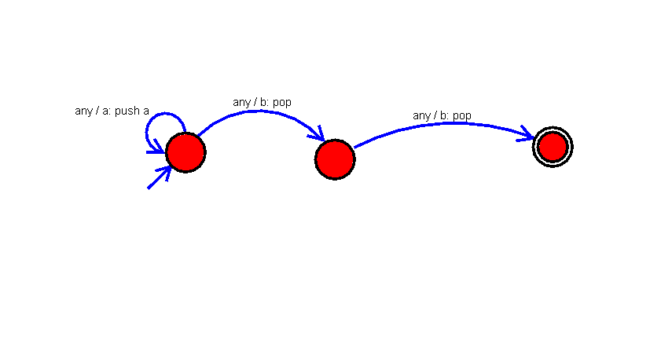

INPUT:

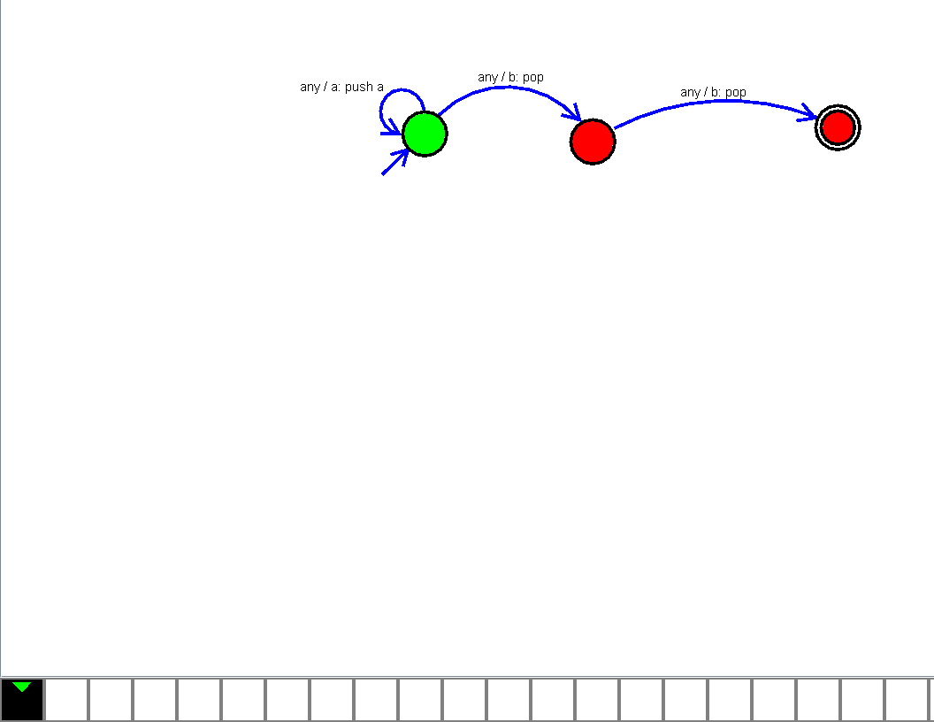

U

OUTPUT:

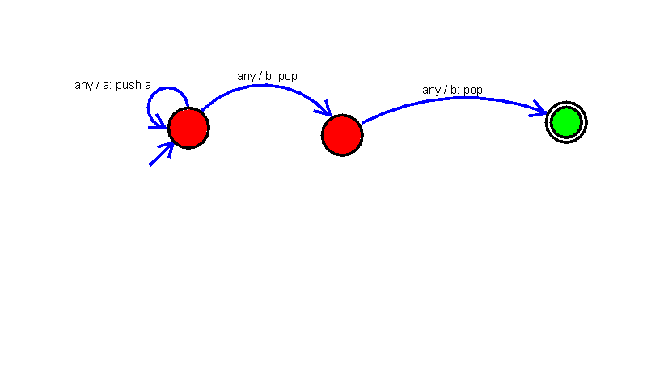

RESULT:

The implementation of Design PDA using simulator to accept the input string aabb

successfully completed.